Year 12 Chemistry Exam Semester 1, 2003 Solutions

PART 1
1c, 2a, 3c, 4b, 5a, 6a, 7a, 8c, 9d, 10d, 11d, 12a, 13b, 14d, 15d, 16b, 17b(or c), 18d, 19c, 20a, 21b, 22a, 23b, 24c, 25d, 26b, 27c, 28a, 29c, 30b

PART 2

Question 1

(a) 2CrO₄²⁻(aq) + 2H⁺(aq)  Cr₂O₇²⁻(aq) + H₂O(l)
Yellow solution turns orange

(b) Co(H₂O)₆²⁺(aq) + 4Cl⁻(aq)  CoCl₄²⁻(aq) + 6H₂O(l)
Pink solution turns blue

(c) 3C₂H₂O₄(aq) + Cr₂O₇²⁻(aq) + 8H⁺(aq)  2Cr³⁺(aq) + 7H₂O(l) + 6CO₂(g)
Colourless oxalic turns green and bubbles formed

(d) 2NO₃–(aq)+ Cu(s) + 4 H⁺(aq) 2NO₂(g) + 2H₂O(l) + Cu²⁺(aq)
Metal dissolves; Vigorous bubbling; brown gas; solution turns green then blue

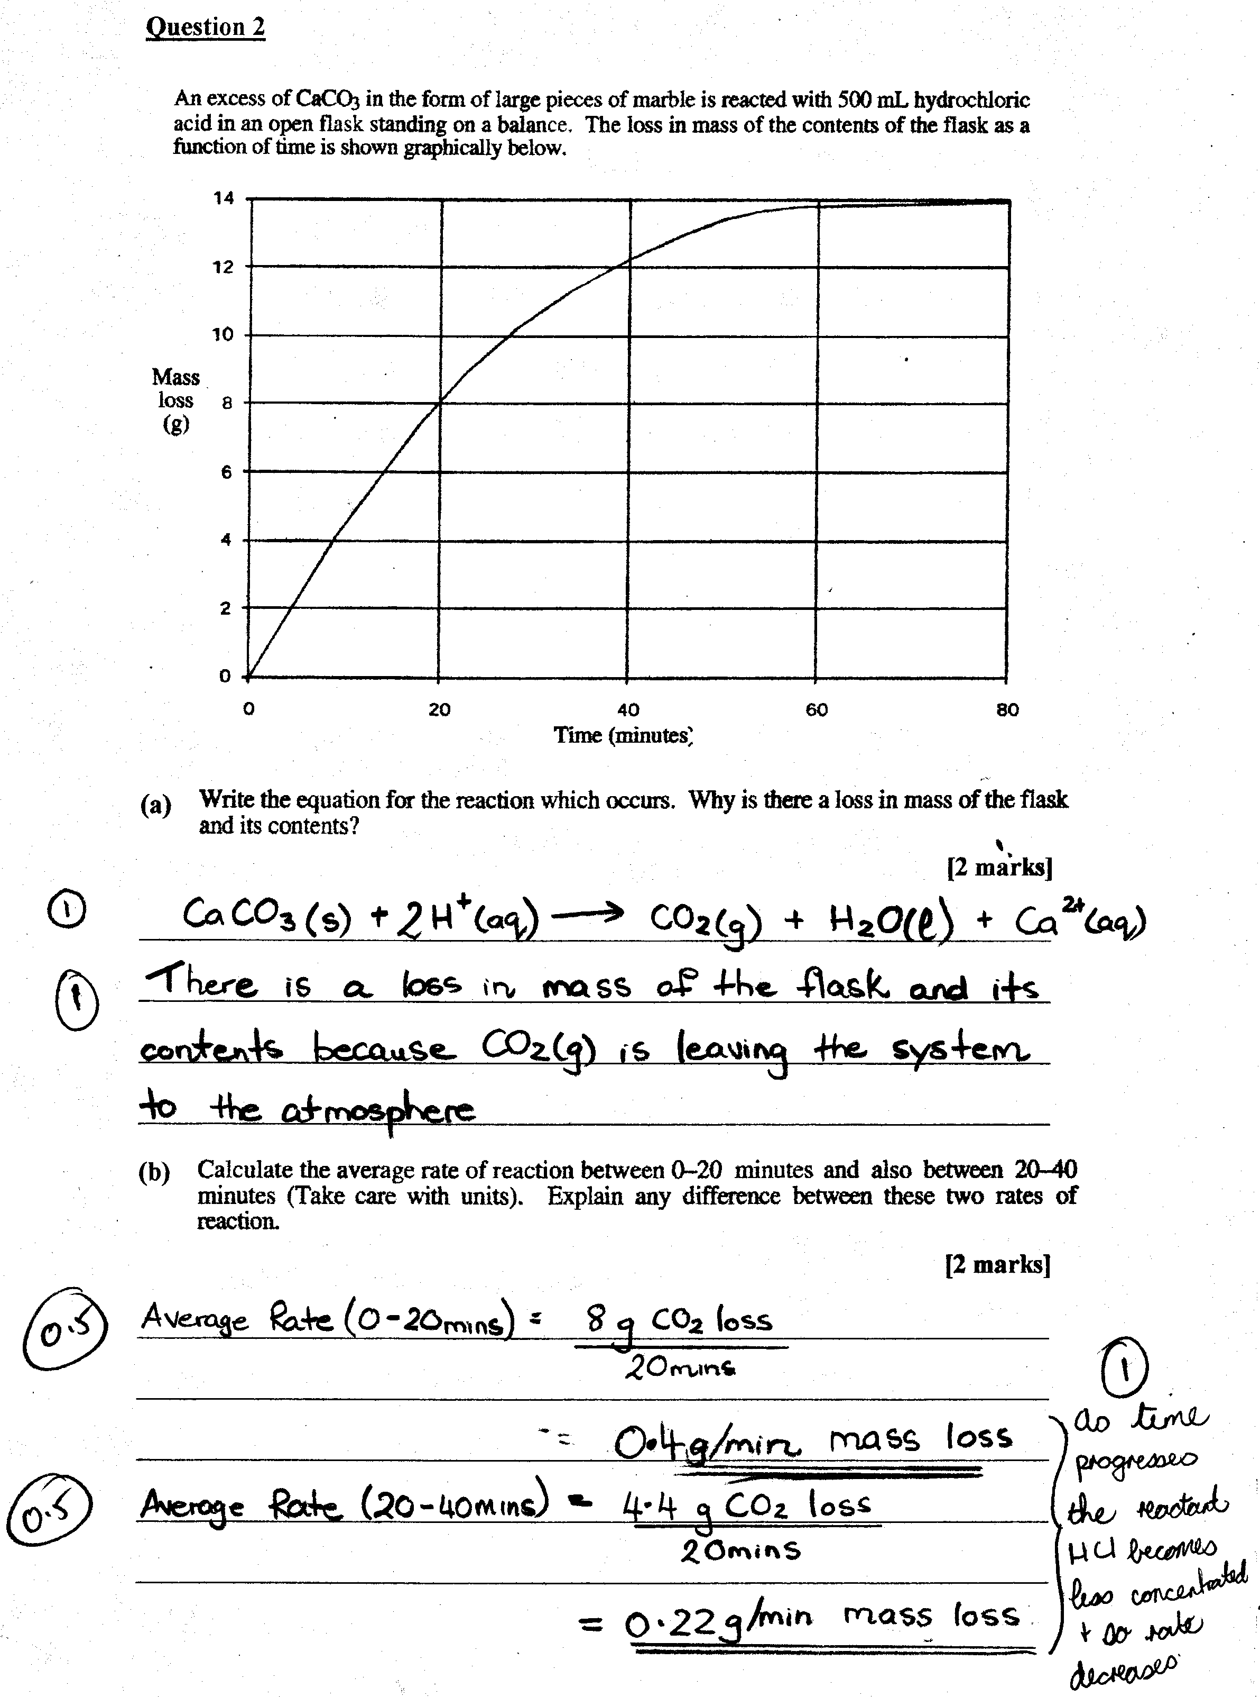
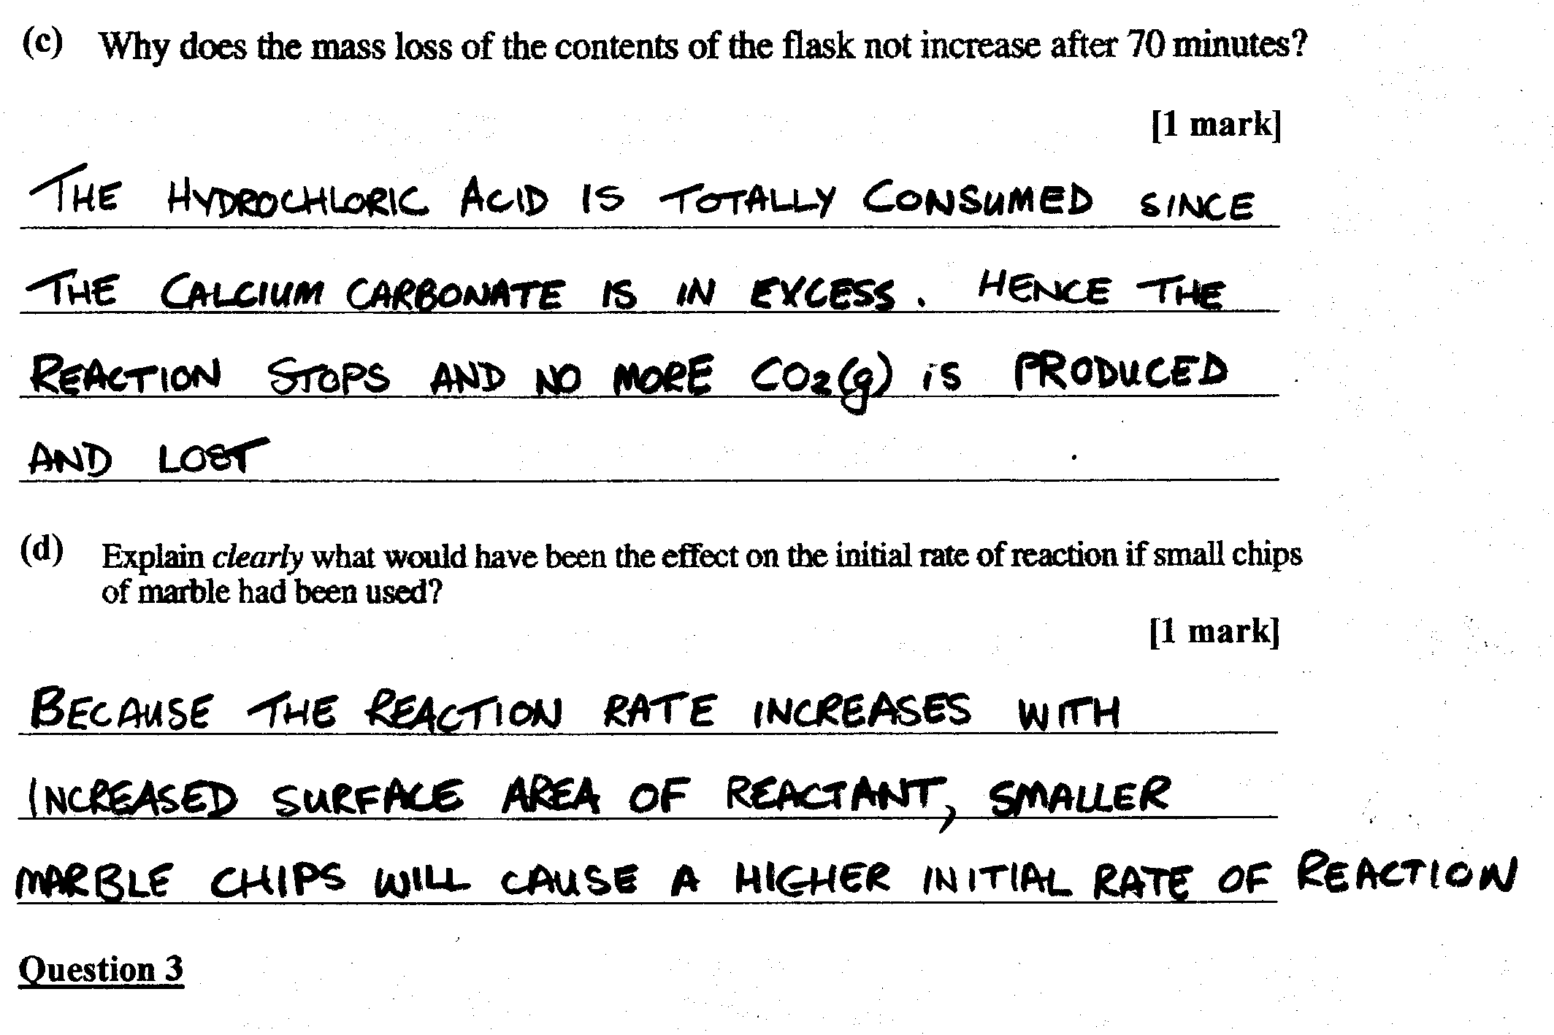
(a) Haber Process: iron/iron oxide
Contact Process: vanadium pentoxide

(b) A catalyst lowers the activation energy barrier of a reaction thus making the forward and reverse reactions faster (1)

Without Catalyst

With Catalyst

Lower Activation Energy Barrier

Potential

Energy
Potential
Energy

Progress of Reaction

Progress of Reaction

(2)
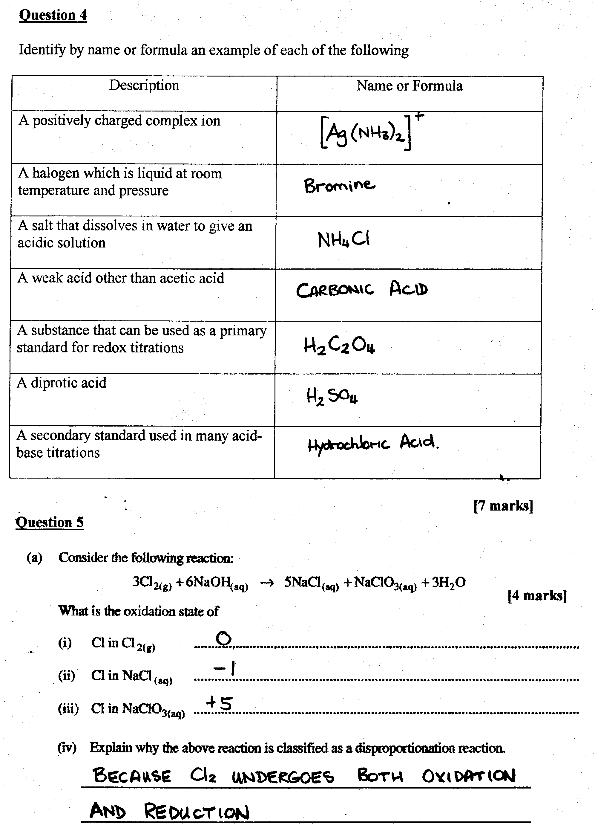

(a)

(b)

(c)

(d)

Question 6

(a) 2 5H₂O(l) + As₂O₃(s)  2H₃AsO₄(aq) +4H⁺(aq) + 4e-
(5)
4e- + 2 6H⁺(aq) + 2NO₃⁻(aq)  N₂O₃(aq) + 3H₂O(l)

2H₂O(l) + As₂O₃(s) + 2H⁺(aq) + 2NO₃⁻(aq)  2H₃AsO₄(aq) + N₂O₃(aq)
+2OH⁻(aq) +2OH⁻(aq)
(1)

2H₂O

4H₂O(l) + As₂O₃(s) + 2NO₃⁻(aq)  2H₃AsO₄(aq) + N₂O₃(aq) +2OH⁻(aq)
(1)
(1)
(b) oxidant: NO₃⁻(aq)
(1)
(c) oxidising agent: NO₃⁻(aq)
(1)
(d) +5

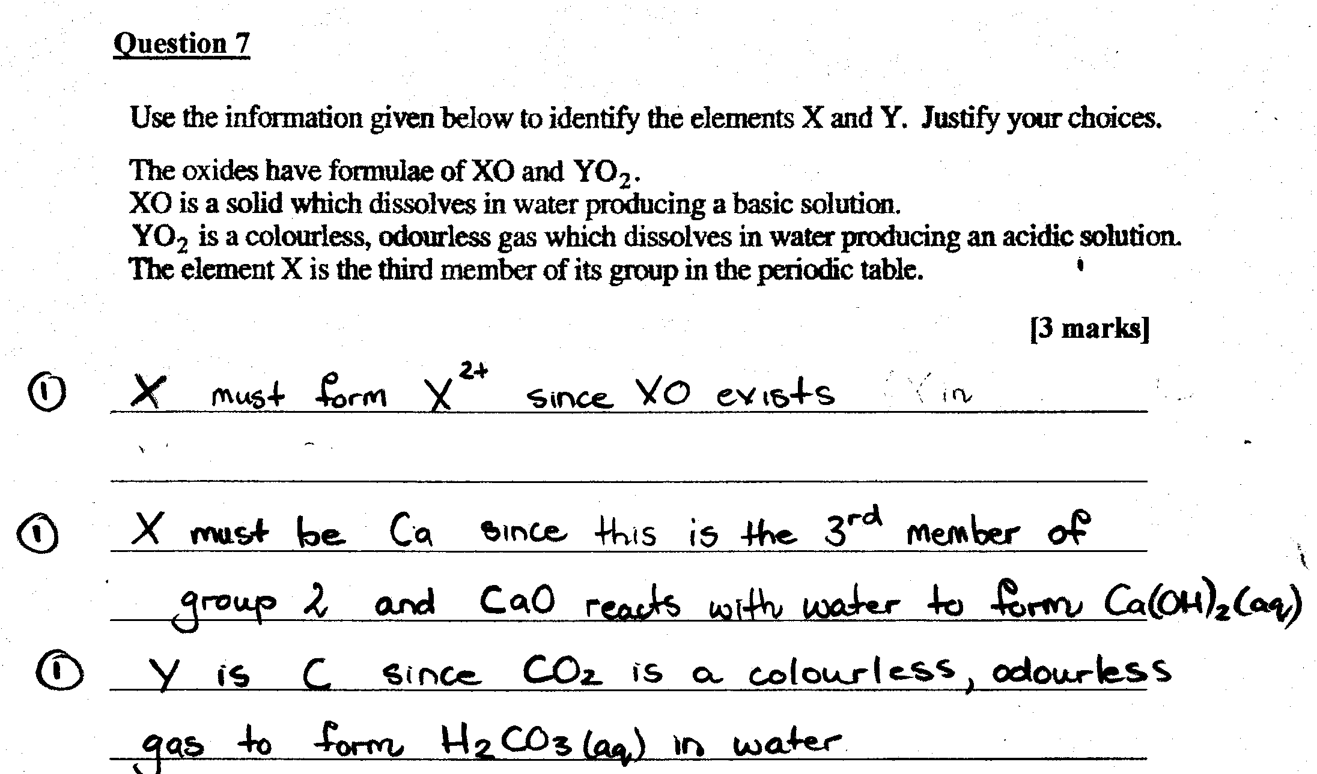

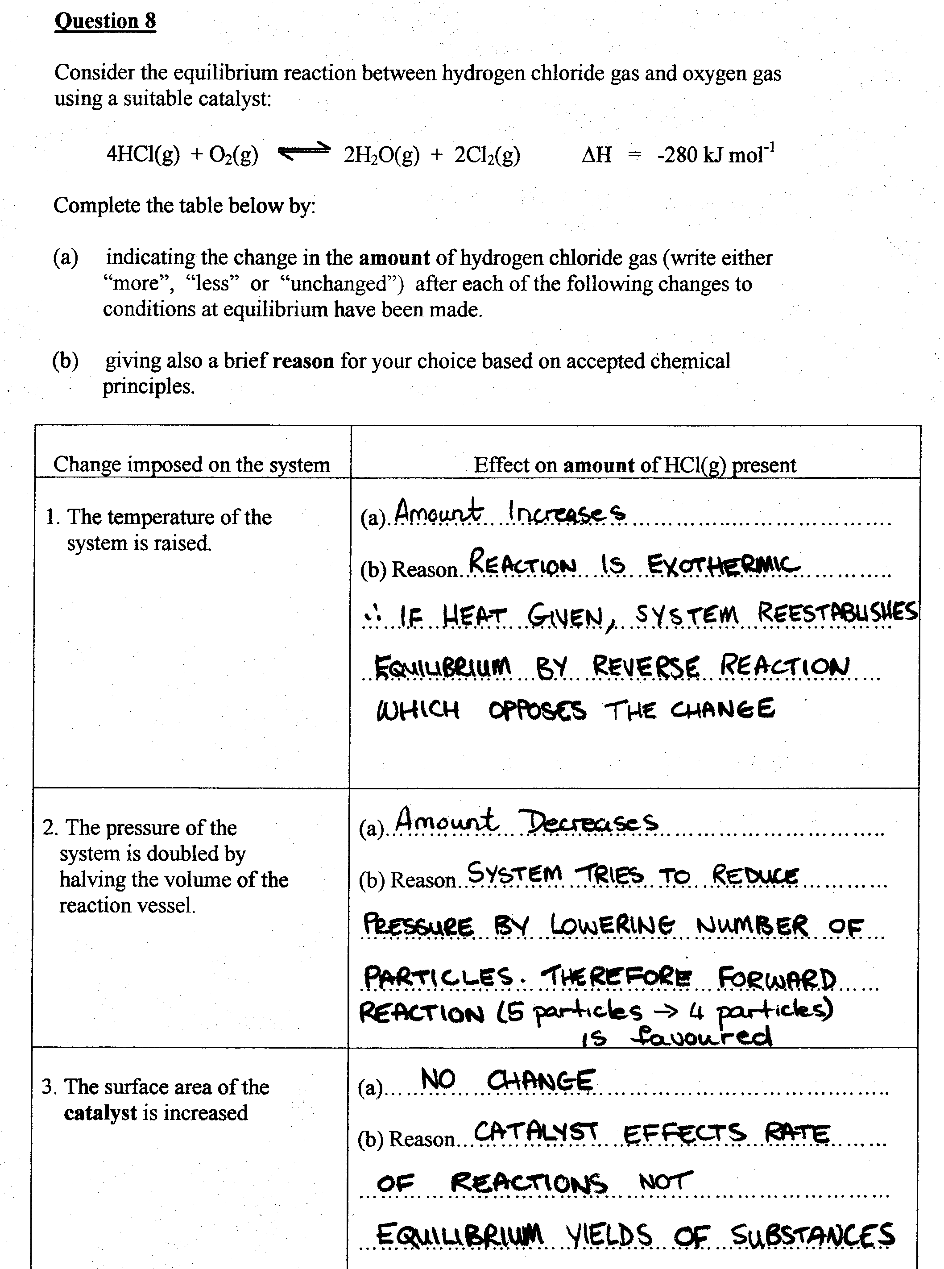

Question 9

(a) The horizontal section of the graph indicates that the system reaches equilibrium (1). This is because the concentration of products and reactant are constant. Chemical equilibrium has constant macroscopic properties with forward and reverse reactions occurring at the same rate (1).

(b) 0.2 moles of A are consumed. This produces 0.4 moles of B and 0.2 moles of C.
Therefore, 1 mol A  2 mol B and 1 mol C.

A 2B + C (2)

(c) K = ([B]²[C])/A =(0.4² x 0.2) / 0.6 = 5.3x10⁻² mol²L⁻² (2)

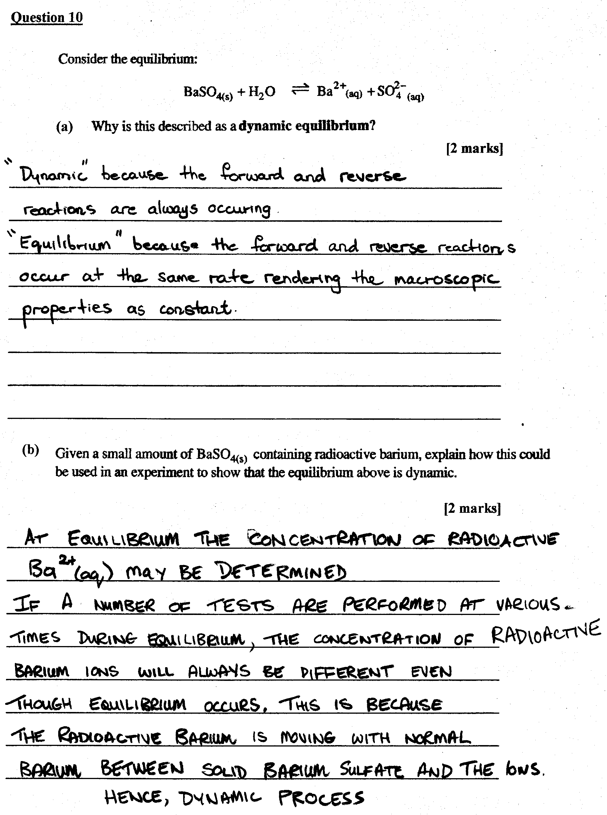
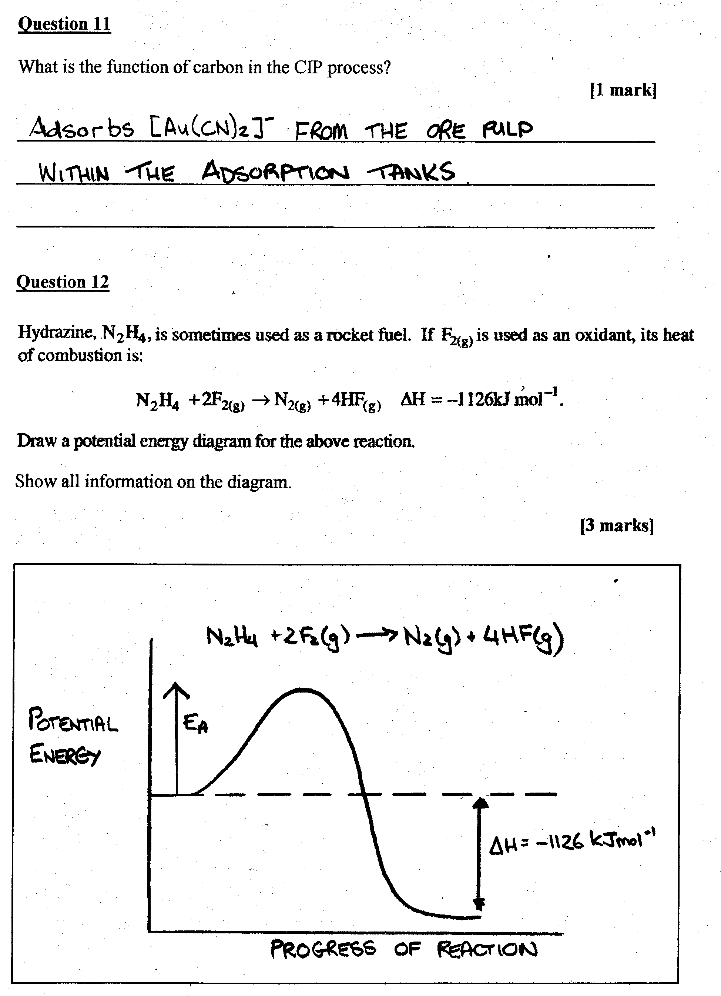

PART 3

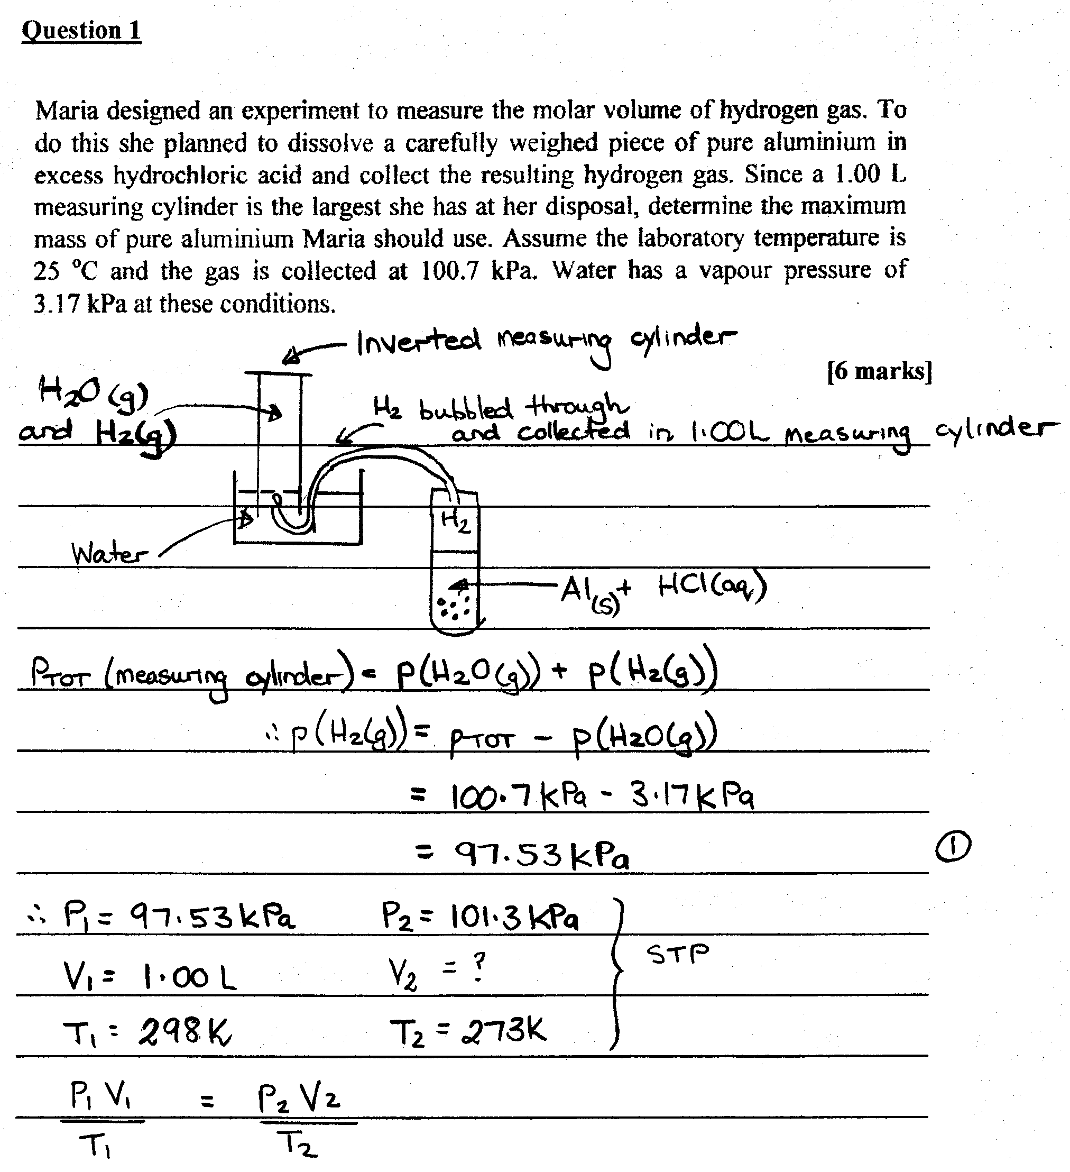
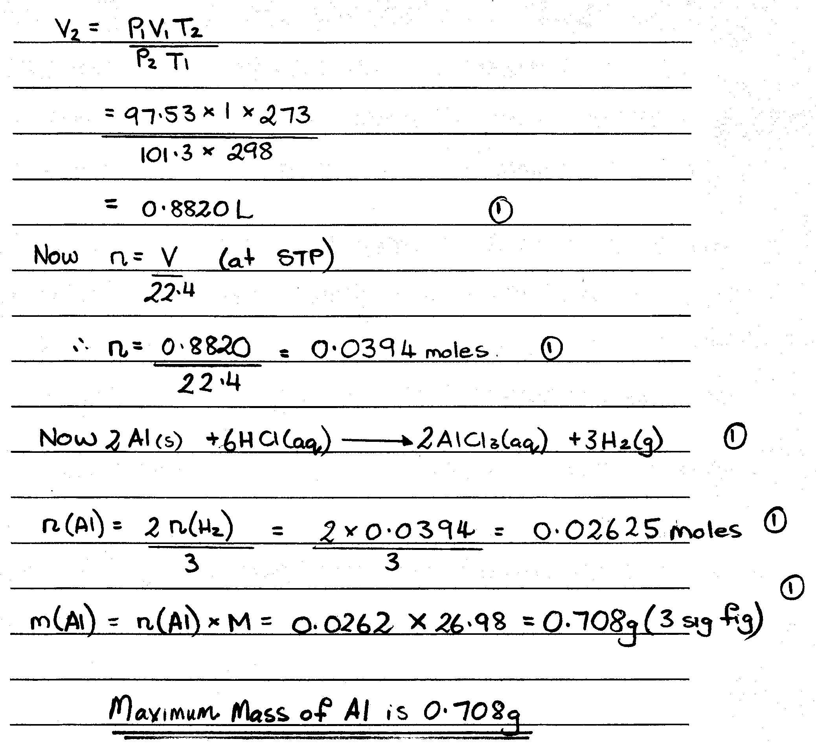
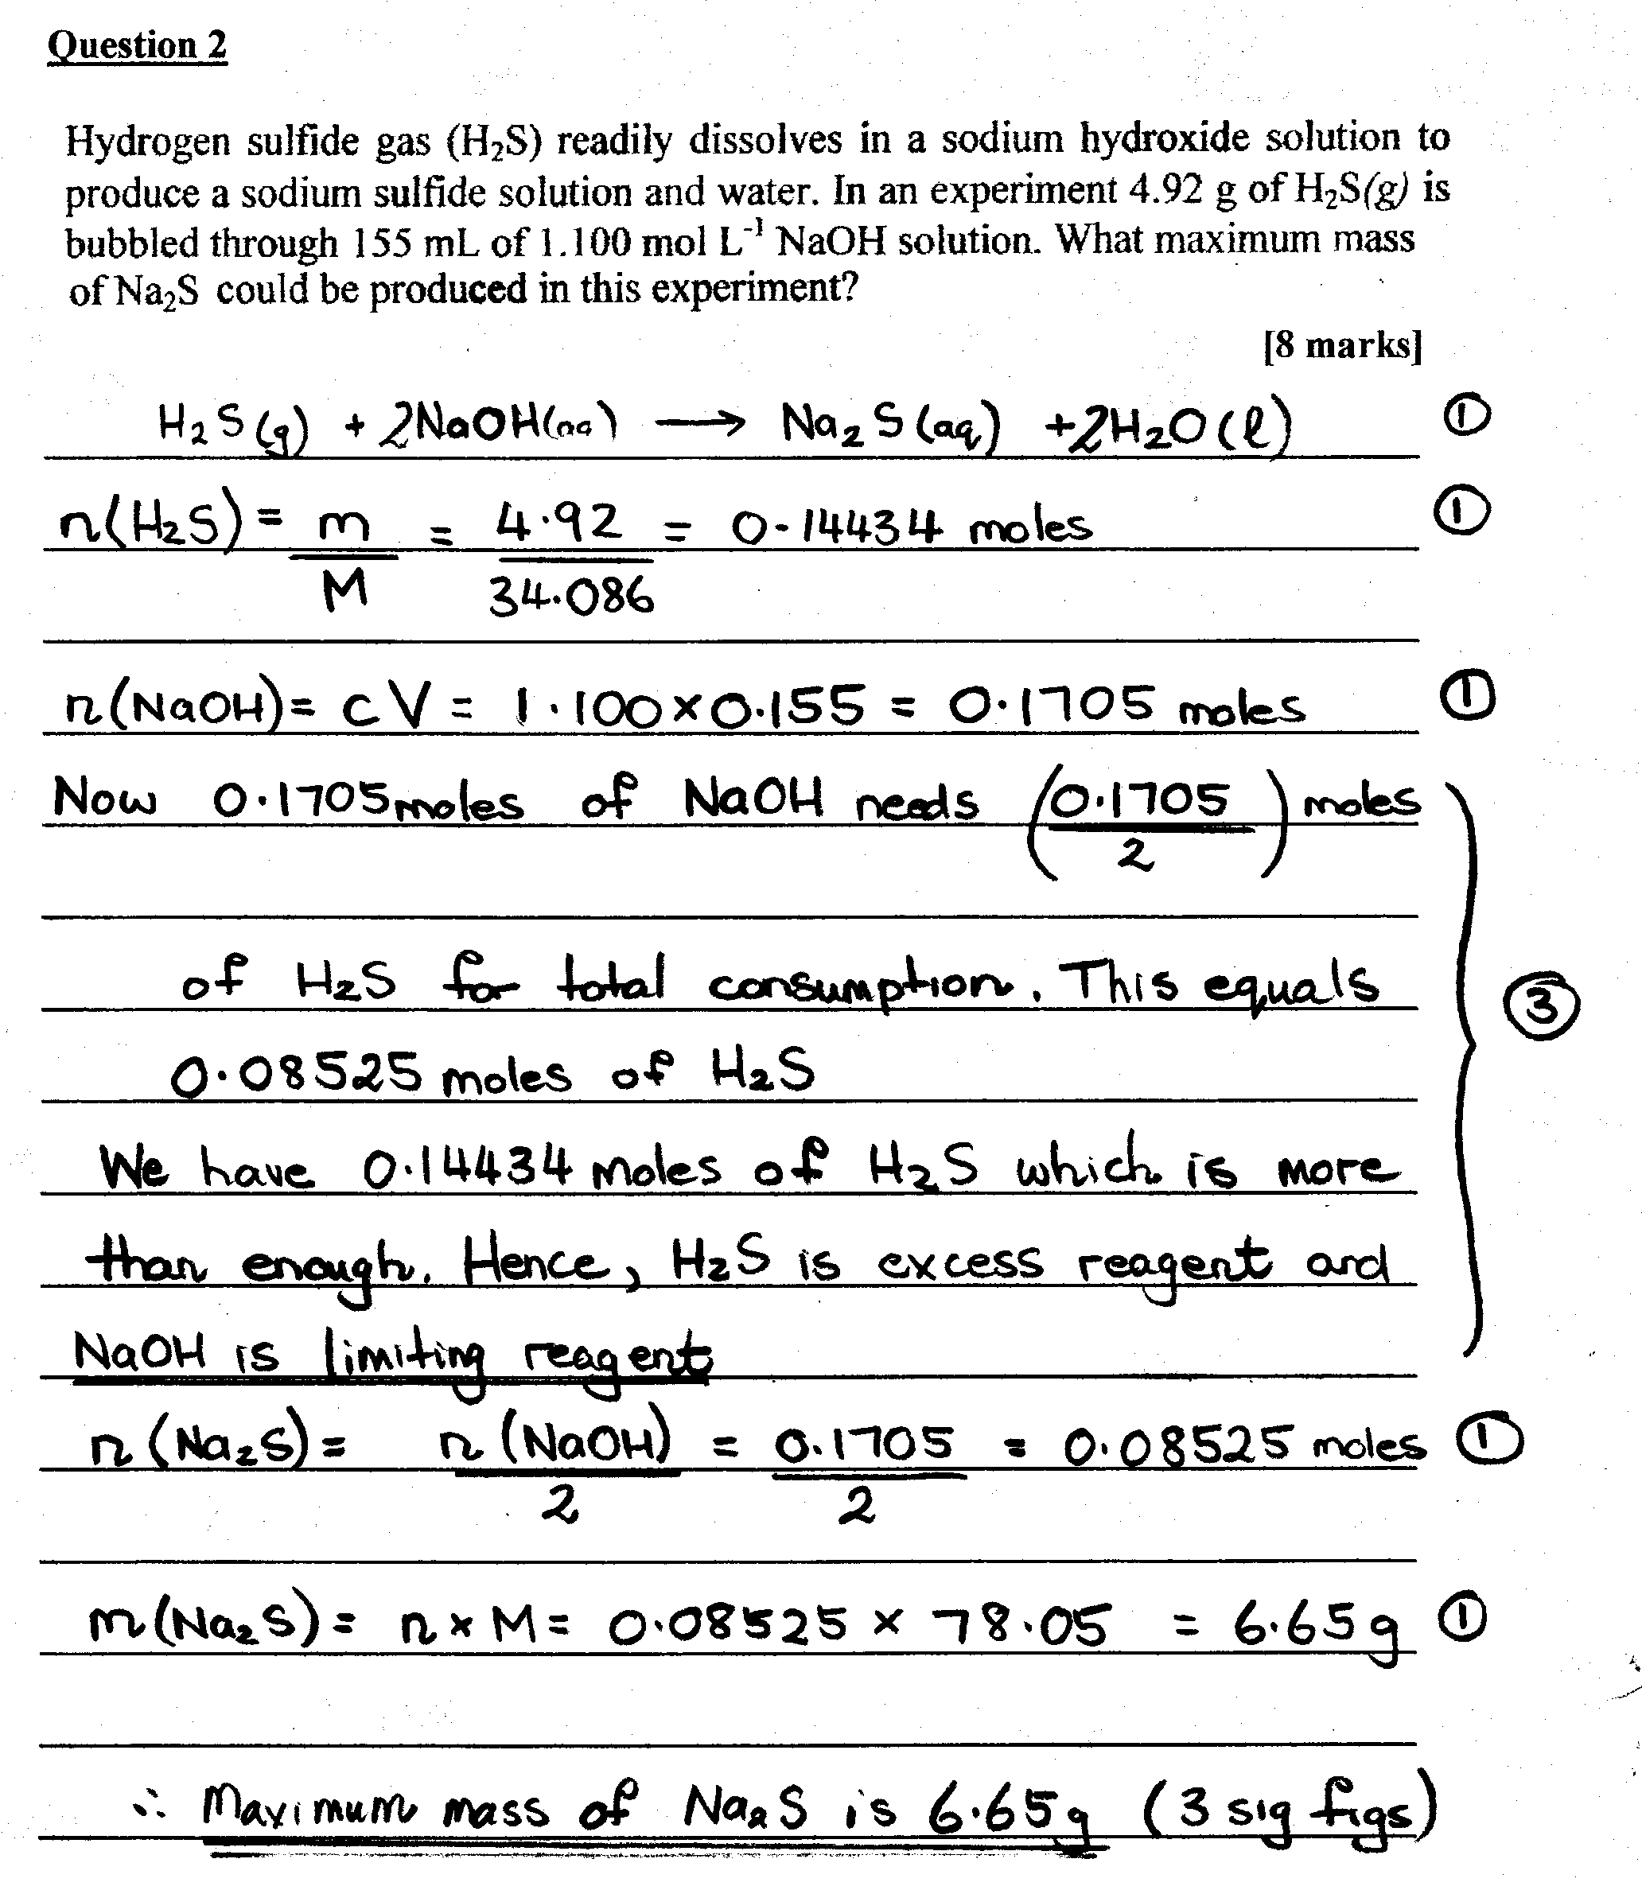
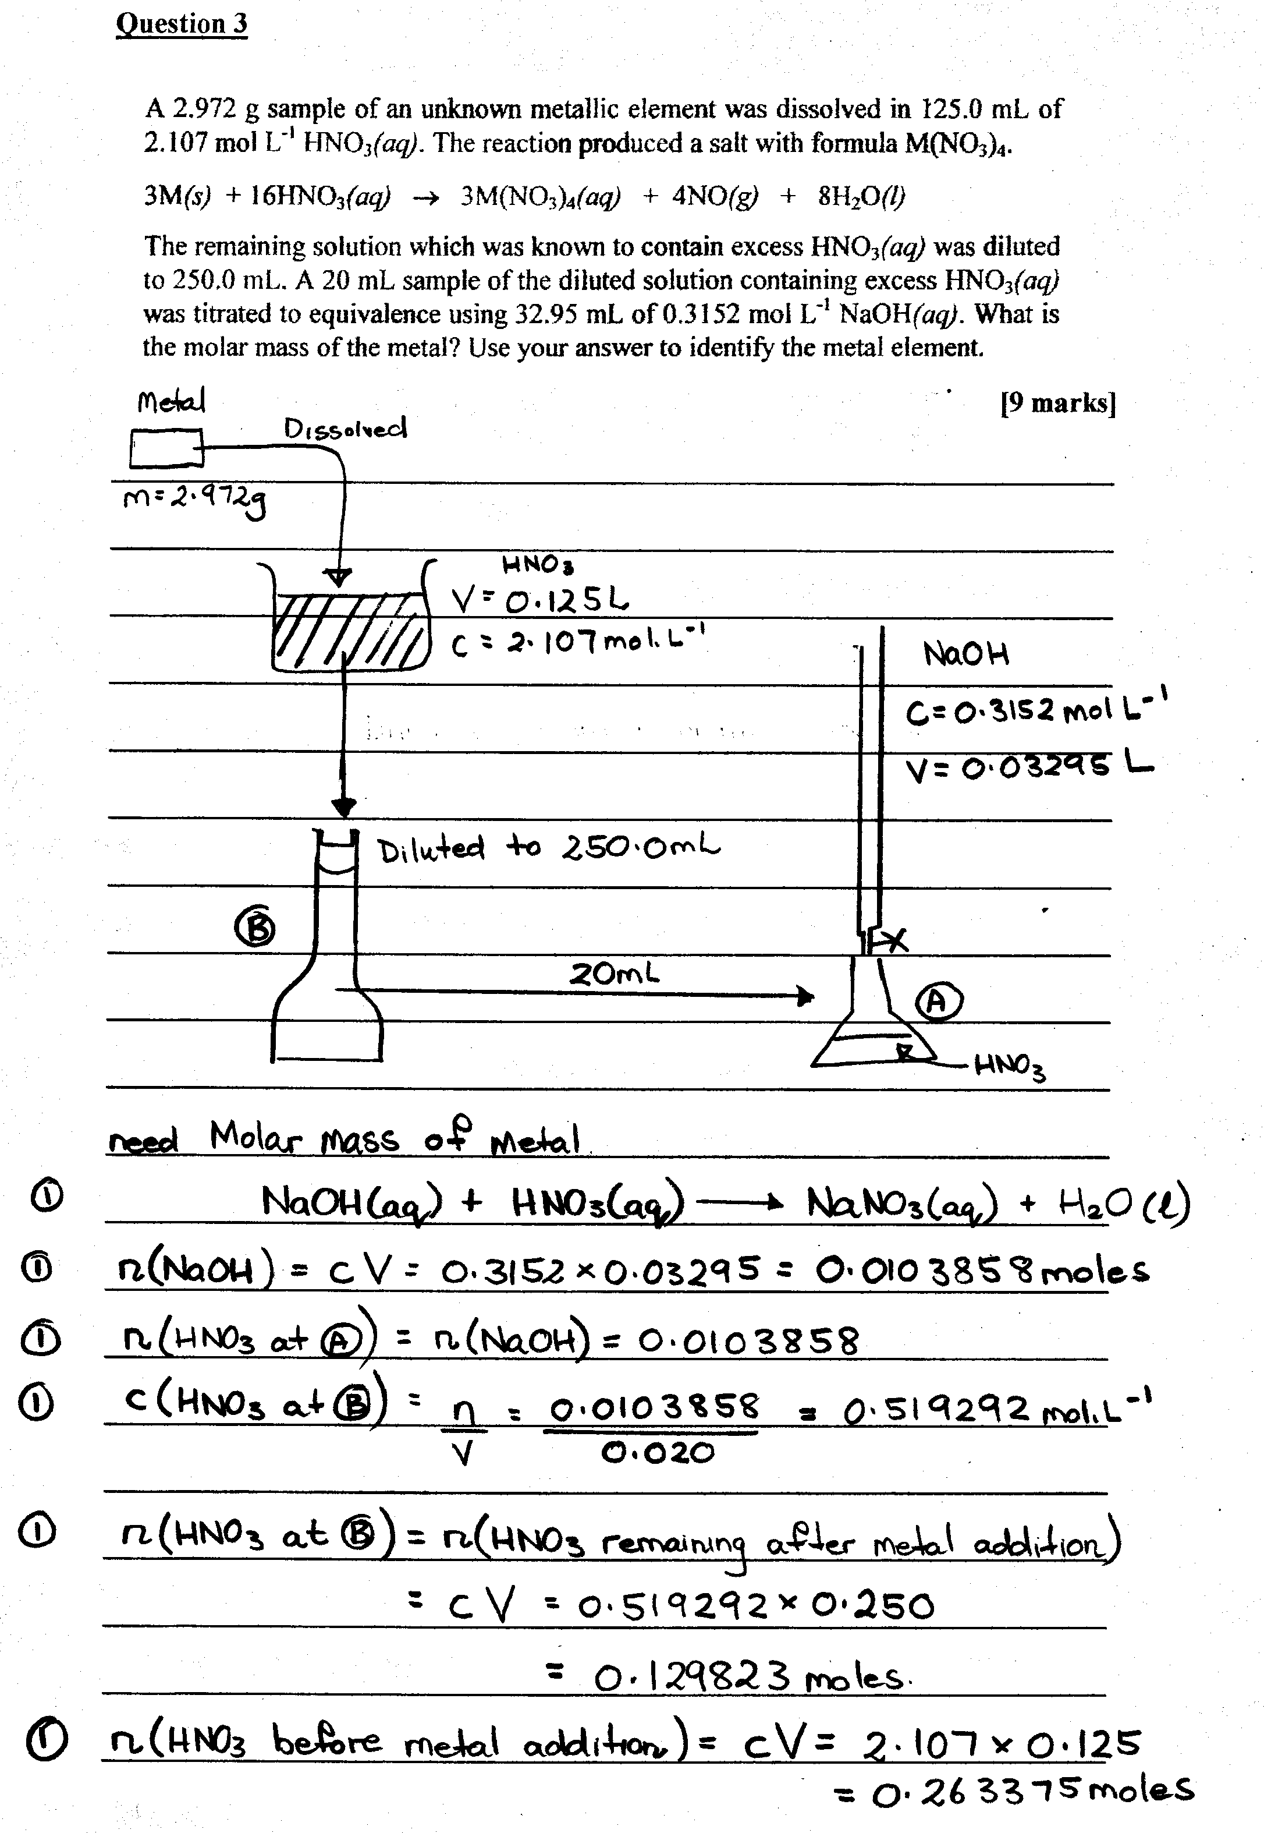
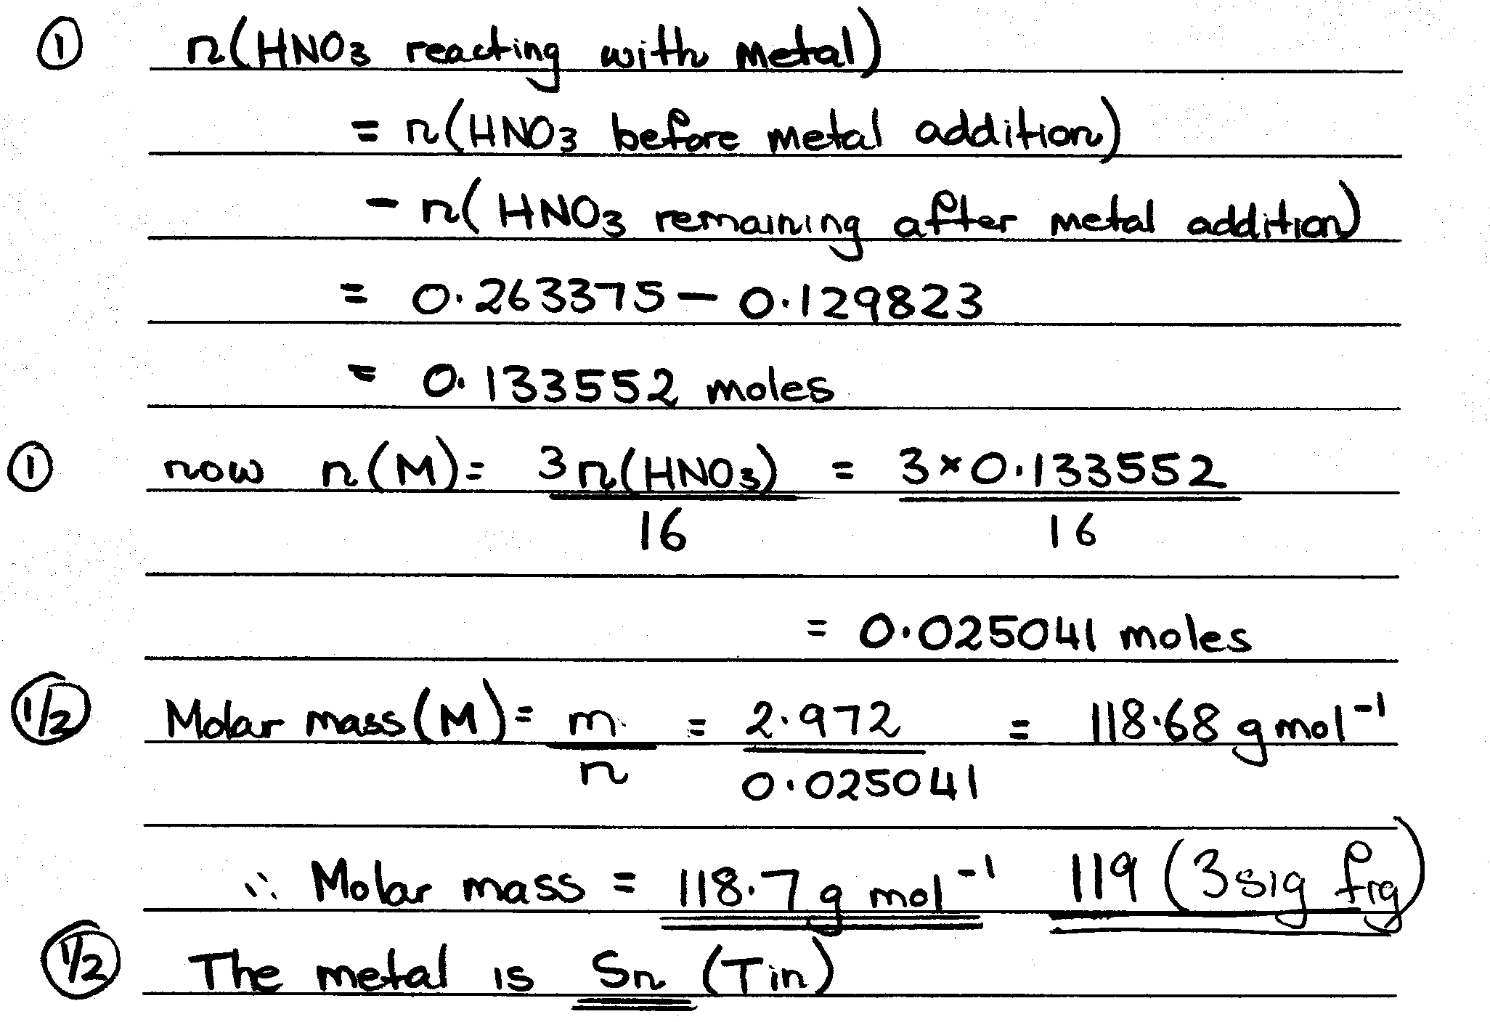
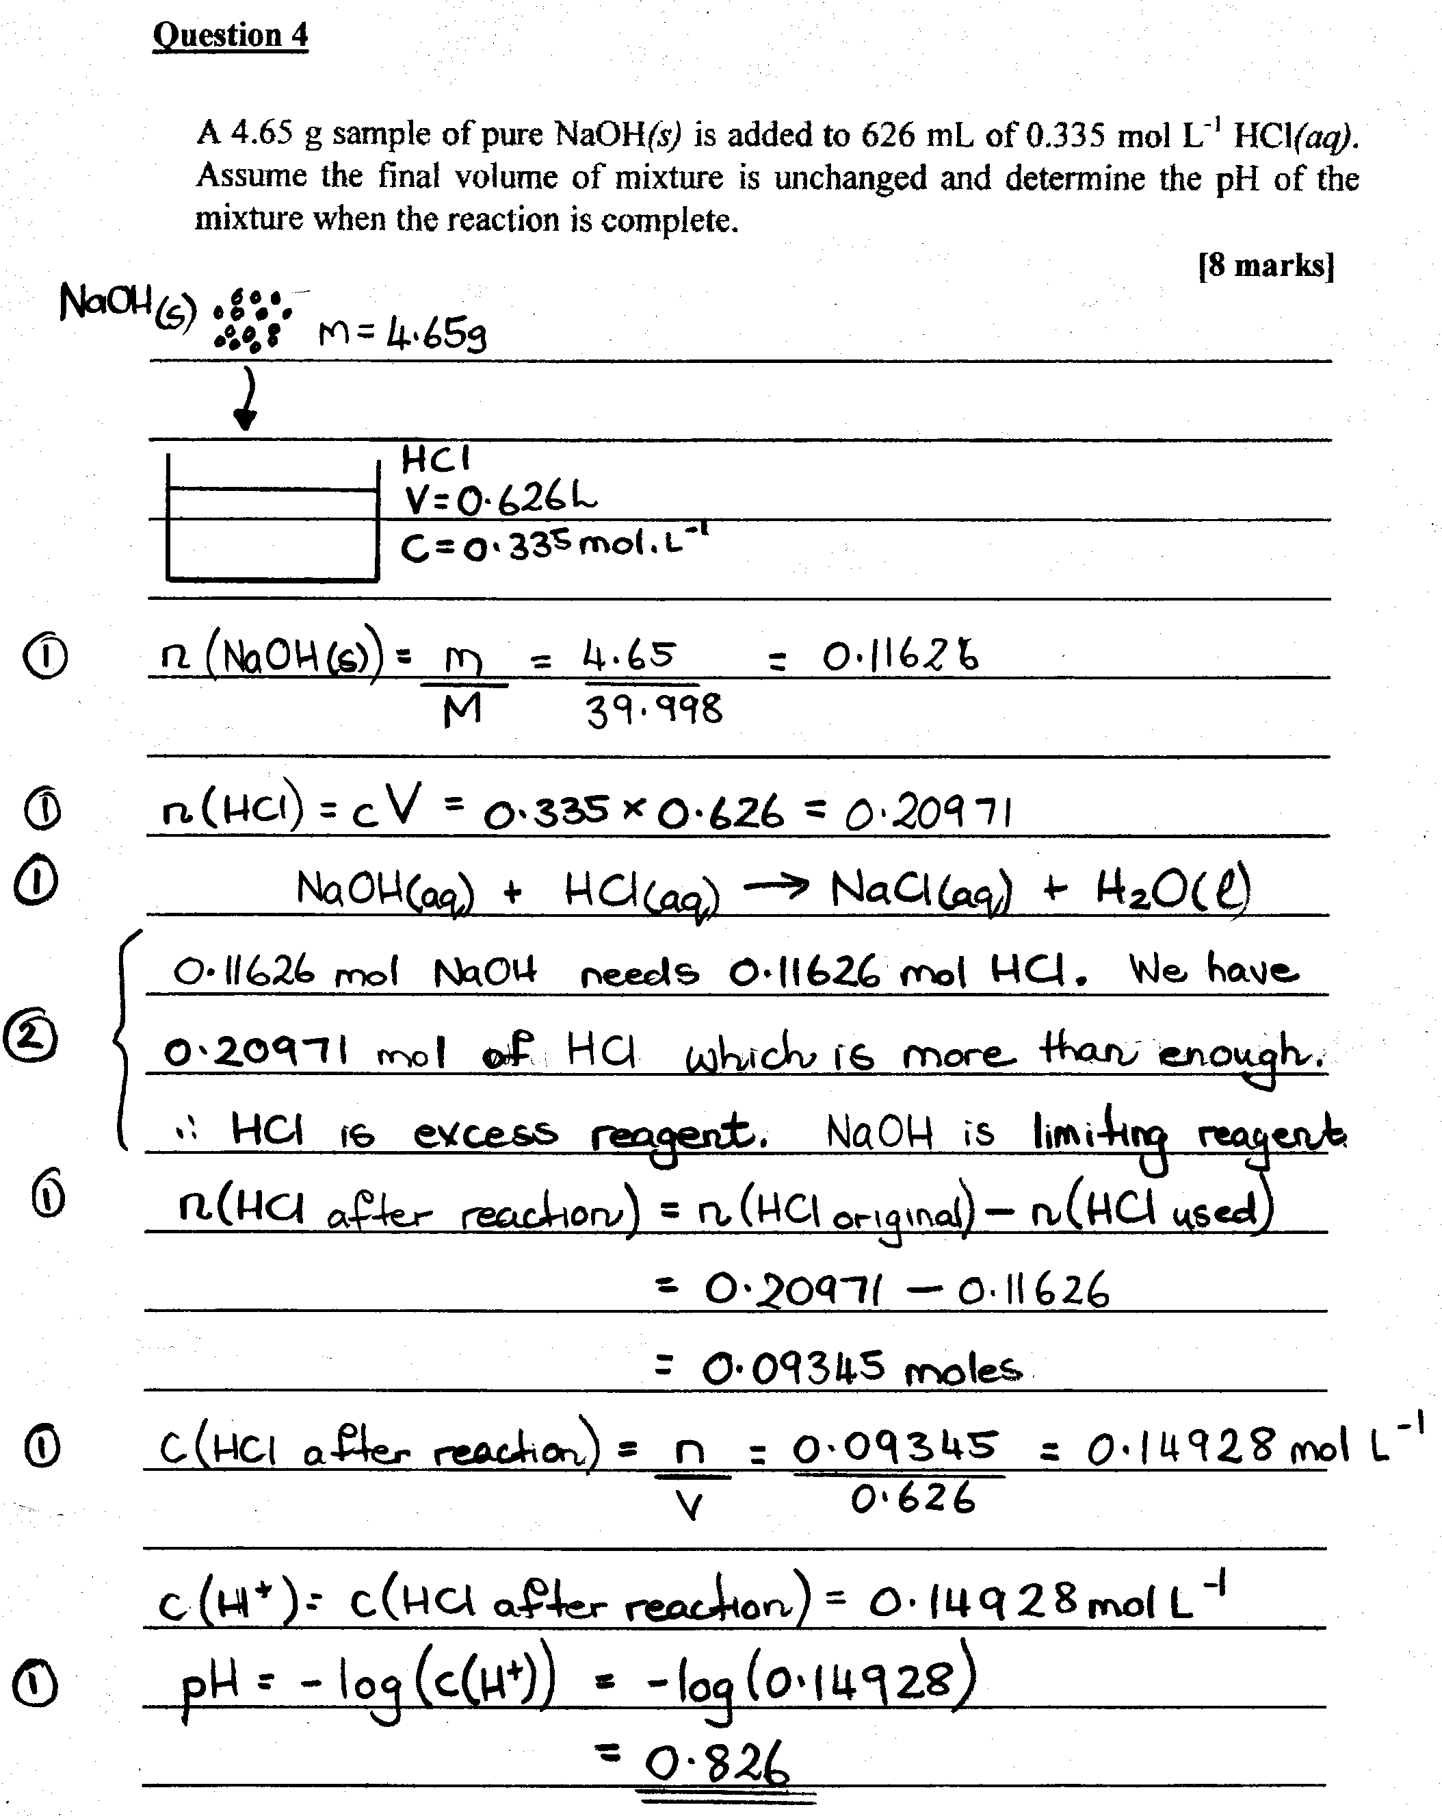
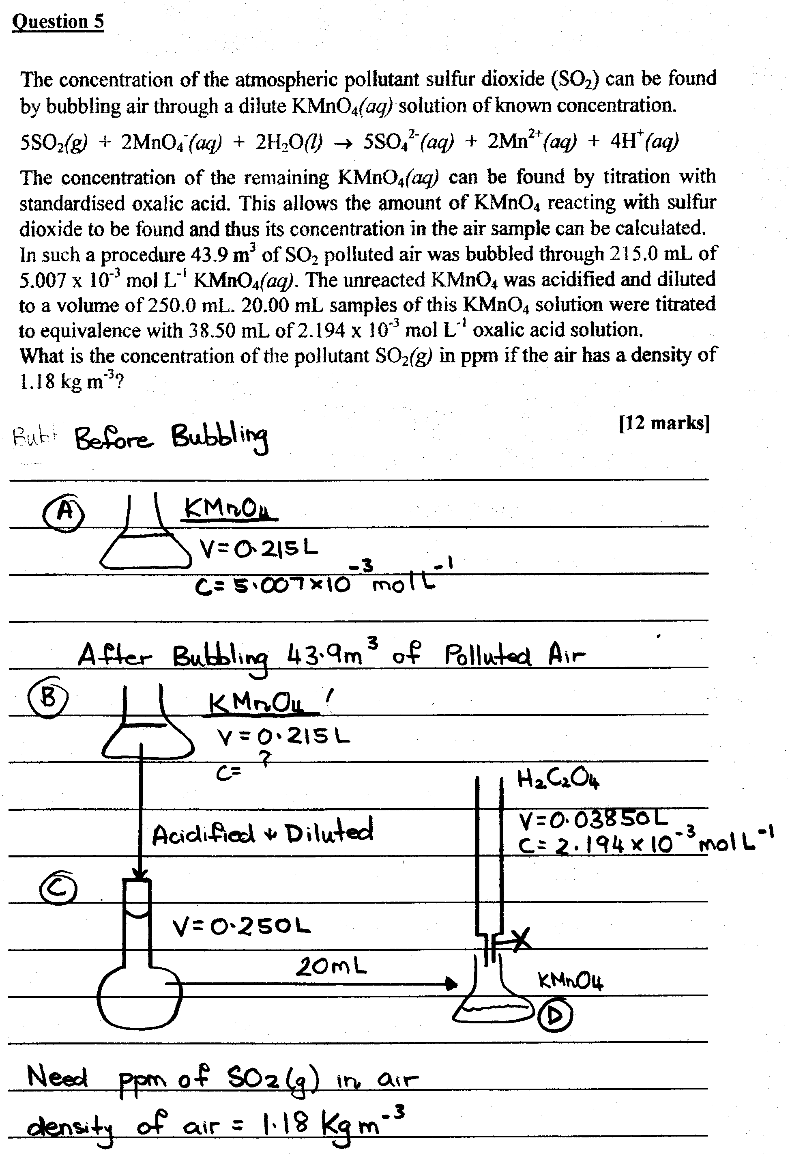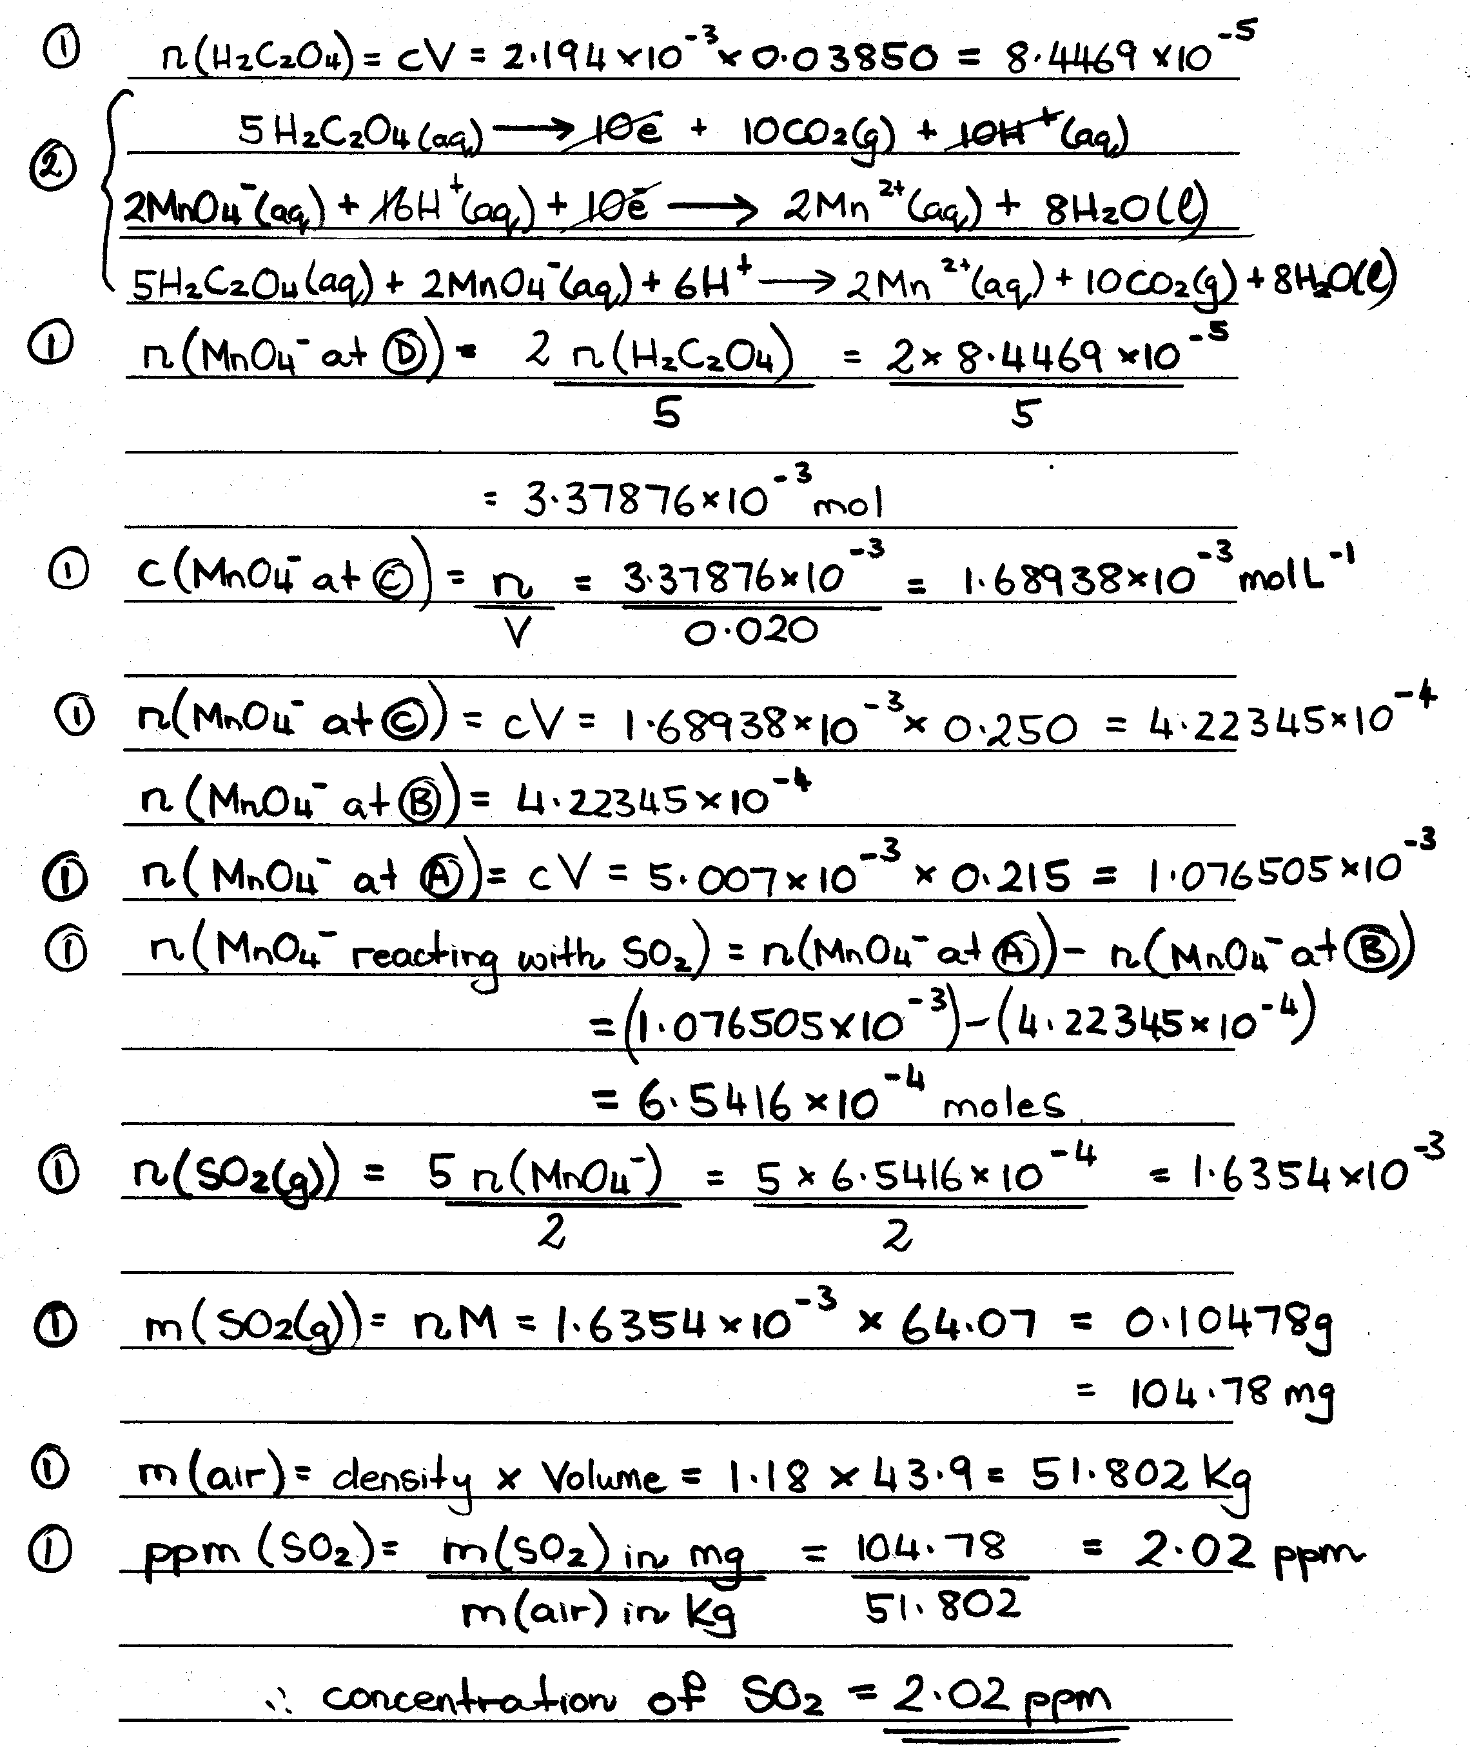
3.37876 x 10⁻⁵ mol
3.37876 x 10⁻⁵ mol
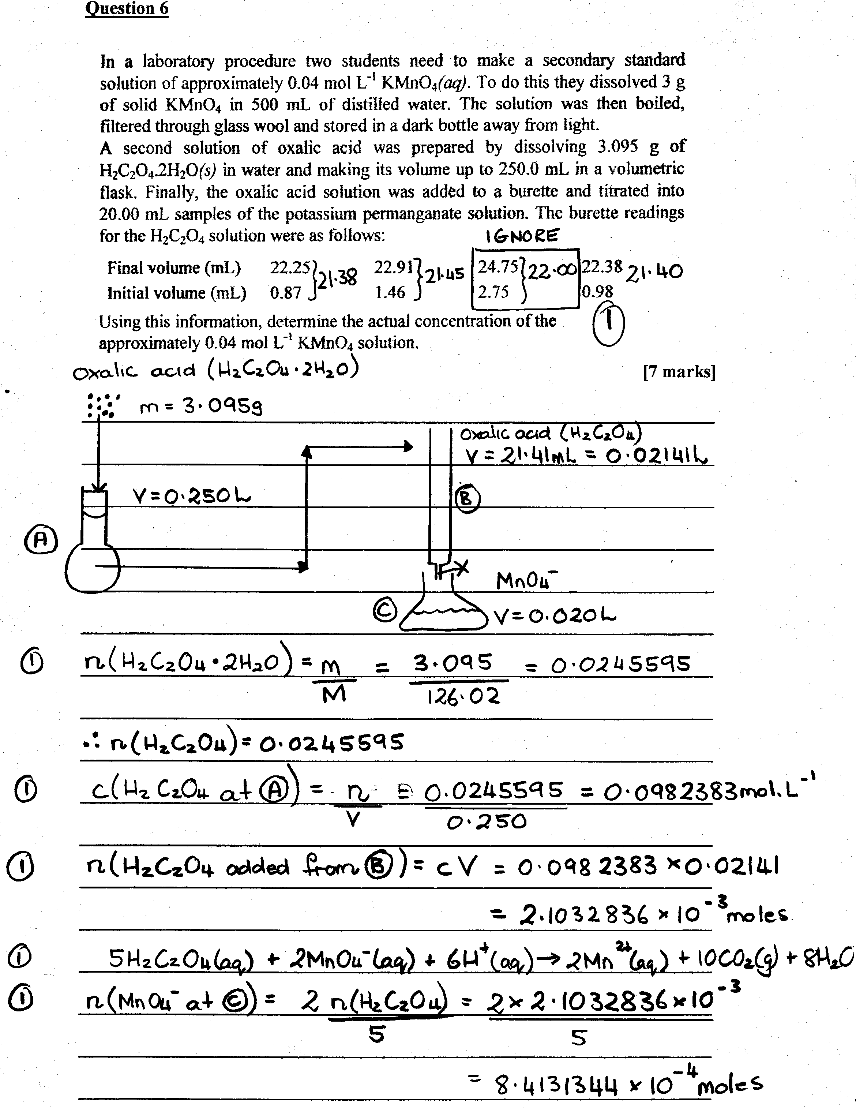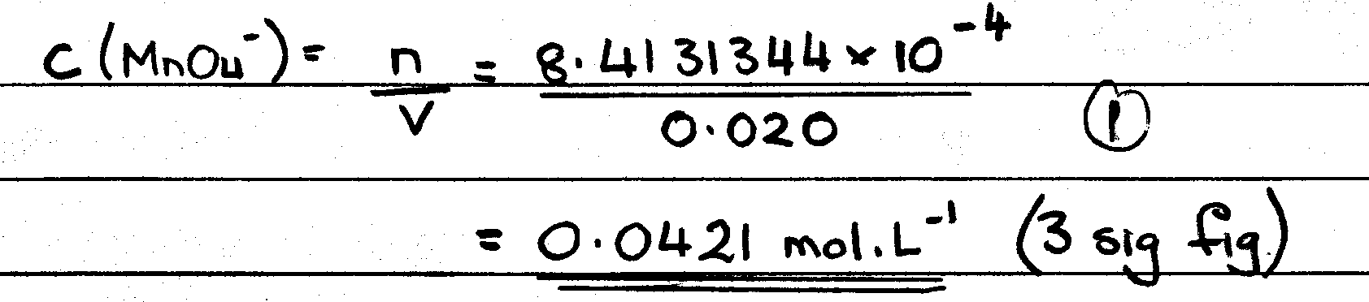
Essay Next Page

Extended Answer 1

Item Presented |  | Reason Why | Details
Definition of Volumetric Analysis  (1 mark) |  |  | Sufficient volume of a known concentration is added to completely react with the substance being analysed (1 mark). From the measured volume and known concentration of the solution used, one can calculate the amount of the substance being determined (1 mark).
Apparatus (1 mark) |  | To emphasise that no other apparatus may be used as they are designed for accuracy in this quantitative procedure (1 mark). | The following glassware would be brought into class and shown to the students (1 mark):
 |  |  | Volumetric Flask  (1 mark) | Holds an accurately known volume indicated by a line etched into the neck of the flask  (1 mark).  Used for the preparation of solutions whose concentrations are to be accurately known. These solutions are called standards (1 mark).  Standards prepared by measuring a mass of a pure substance in water to produce a definite volume of solution (1 mark).  Must be rinsed with water before use (1 mark).
 |  |  | Pipette  (1 mark) | Used to accurately deliver a specific volume of solution such as 5.00 mL, 10.00 mL or 20.00 mL (1 mark).  Used to deliver the appropriate volume of solution into a conical flask prior to titration  (1 mark).  Must be rinsed with the solution before use (1 mark).
 |  |  | Burette  (1 mark) | Used to accurately deliver variable volumes of solution (1 mark).  Usually graduated from 0.0 mL to 50.0 mL with an error of 0.02 mL (1 mark).  The difference between the initial and final readings on the burette indicates the volume of solution delivered in a titration (1 mark).  Must be rinsed with the solution before use (1 mark).
Acid/Base Titration  (1 mark) | Definition  (1 mark) |  | Sufficient volume of a known concentration of an acid (or base) is added to completely react with the base (or acid) being analysed. From the measured volume and known concentration of the acid used, one can calculate the concentration of base being determined (1 mark).
Acid/Base Titration  (1 mark) | Standard Solution  (1 mark) |  | One with an accurately known concentration (1 mark)
Acid/Base Titration  (1 mark) | Standard Solution  (1 mark) |  | Primary Standard  (1 mark) | An accurately measured mass of a substance is dissolved in water in a volumetric flask to form a known volume of solution (1 mark).  The substance must be obtainable in a very pure form with a known formula (1 mark).  The substance should not alter during weighing (1 mark).  It should have a reasonably high relative formula mass to minimise weighing errors  (1 mark).  Common ones are sodium carbonate and hydrated oxalic acid (1 mark).
Acid/Base Titration  (1 mark) | Standard Solution  (1 mark) |  | Secondary Standard  (1 mark) | A solution whose exact concentration is determined by titration against another standard solution (1 mark).  Example: hydrochloric acid standardised by standard sodium carbonate (1 mark).
Acid/Base Titration  (1 mark) | Indicators  (1 mark) | Students need to select the correct indicator so that the point of complete reaction is determined. If this is not accurate, the entire procedure fails as an analytical tool (1 mark). | An indicator is added to the solution in the conical flask so that a colour change when the neutralisation reaction is complete (1 mark).  Equivalence point: the point at which chemically equivalent amounts of acid and base have been added  (1 mark).  End point: the point at which the analyst sees a colour change (1 mark).  One wants the end-point to be as close to the equivalence point as possible (1 mark).  A table of indicators for different pH ranges would be given to students (1 mark).
Acid/Base Titration Demo (1 mark) |  | Students may see how standards are prepared (1 mark).  Students may see how a titration is done (1 mark).  Students informed of the little “tricks” to make sure accuracy is maintained.  Students may know how to perform the calculation. (1 mark) | Preparation of standard sodium carbonate solution (1 mark).  Preparation of standard hydrochloric acid (1 mark).
Student practice  (1 mark) |  | Hands on practice is the best way to gain further understanding and to build precision and accuracy  (1 mark). | Preparation of standard sodium carbonate solution (1 mark)  Preparation of standard hydrochloric acid (1 mark)

4 marks spelling 4 marks grammar
Total: /59 x 0.34 to make a mark out of 20.

Extended Answer 2

Main Point | Details
Contrasting the Chemical Purification/Extraction of Fe/Au | In nature, gold is mainly found as the free element (0 oxidation state). Its extraction involves the following changes in the oxidation state of gold: 0  +1  0 (1 mark). The ore is leached with cyanide solution:  4Au(s) + 8CN⁻(aq) + 2H₂O(l) + O₂(g)  4[Au(CN)₂]⁻(aq) + 4OH⁻(aq) (1 mark)  Here, gold moves from an oxidation state (OS) of 0 to +1.  The dissolved [Au(CN)₂]⁻ is separated from other materials (pulp) by adsorption on activated carbon in adsorption tanks (1 mark). The [Au(CN)₂]⁻ is then stripped from the carbon (1 mark) and the Au recovered by electrolysis which causes the following:  4[Au(CN)₂]⁻(aq) + 4OH⁻(aq)  4Au(s) + 8CN⁻(aq) + 2H₂O(l) + O₂(g) (1 mark)  Here, gold move from an OS of +1 back to 0.  On the other hand, iron is found in an OS of +3 and its extraction has the following change in OS: +3  0 (1 mark). Carbon monoxide gas reduces the iron ore to iron:  3CO(g) + Fe₂O₃(s)  2Fe(l) + 3CO₂(g) (1 mark)  Unlike gold extraction iron extraction does not use adsorption or electrolysis (2 marks). The liquid iron is heavier than all other materials and simply sinks to the bottom of the blast furnace and then is tapped out (1 mark).  In gold extraction, the carbon is in the form of activated charcoal and separates the required product by adsorption (1 mark).  In iron extraction, the carbon is in the form of coke and separates the required product by oxidising to CO which then reduces the iron oxide (1 mark).
Comparing the Chemical Purification/Extraction of Fe/Au | The gold mud produced from electrolysis is purified in a similar manner to the extraction of iron from iron ore.  Like iron ore, the gold mud is smelted at high temperatures (1 mark).  Like iron extraction, undesirable impurities form a slag layer which floats on top of the gold  (1 mark).  Like iron, the gold is poured into moulds and solidifies (1 mark).  The purities of the resulting iron and gold are approximately the same: respectively 98% and 95% (1 mark).  Both iron and gold extraction require the use of carbon (1 mark).  Both iron and gold extraction use redox reactions (1 mark).
How the differences in the properties of gold and iron are reflected in their everyday use. | Gold is chemically unreactive whereas iron is reactive readily oxidising to iron(II) and iron (III) (1 mark). It is therefore understandable as to why gold is used as an international monetary standard or as teeth fillings whereas pure iron is not. We don’t want our monetary standard or fillings to react! (2 marks)  Iron (in its oxide from) is found in greater amounts than gold (1 mark). This is why it is used more extensively than gold especially in the building industry. It would be too expensive to use gold in the building industry (1 mark).  Unlike gold, iron is used in the building industry because it is strongly magnetic and this property is extremely useful in many mechanisms such as motors and bells (1 mark).  Gold is a prettier metal than iron. It is shiny and yellow (1 mark). This, as well as it rarity and unreactive nature, make it a popular metal for jewellery (1 mark).  Gold is a better electrical conductor than iron. This is why gold is used to make electrical connections.
Spelling | (2 marks)
Grammar | (2 marks)
Total: /30 x 0.67 to make a mark out of 20.

